IMPLEMENTING CRM FOR RESULT TRACKING OF A CANDIDATE WITH INTERNAL MARKS - (ADMIN)



|  |
| --- |
|  |

*Presented by*

*Lakireddy balireddy college of engineering*

*M.Vamsi(20761A0373)*

*P.Prabhas(20761A0379)*

*A.T.E.Manikanta(21765A0321)*

*K.Gopi krishna(21765A0325)*

*M.Vara prasad(21765A0328)*

# Introduction

Salesforce, Inc. Is an American cloud-based software company headquartered in San Francisco, California. It provides customer relationship management (CRM) software and applications focused on sales, customer service, marketing automation, e-commerce, analytics, and application development.

Founded by former Oracle executive Marc Benioff, Salesforce quickly grew into one of the largest companies in the world, making its IPO in 2004. Salesforce's continued growth makes it the first cloud computing company to reach US$1 billion in annual revenue by fiscal year 2009,and the world's largest enterprise software firm by 2022.

Today, Salesforce is one of the largest technology companies in the world, and as of September 19, 2022, is the 61st largest company in the world by market cap with a value of nearly US$153 billion. Salesforce ranked 136th on the most recent edition of the Fortune 500, making US$26.5 billion in 2022. Since 2020, Salesforce has also been a component of the Dow Jones Industrial Average.

# Salesforce Administrator

A Salesforce Administrator solves business problems by customizing the Salesforce Platform. They build, configure, and automate technology solutions to deliver business value. Salesforce Administrators work with stakeholders to define system requirements and customize the platform. Most importantly, they enable users to get the most out of Salesforce technology.

A Salesforce Admin best understands how to make the platform work for their company’s goals. Some organizations may employ just one admin; some employ many people in this role.

Core responsibilities include supporting users, managing data, maintaining security standards, and delivering actionable analytics. A Salesforce Administrator’s colleagues can rely on them to:

* Maintain the platform
* Make it as easy as possible for users of any technical level to use Salesforce
* Stay current on the platform’s new tools, capabilities, and updates

Think of Salesforce Administrators as your trusted advisors on all things Salesforce. They are a vital bridge between business and technology.

# Proposal

It saves lot of time on result tracking. It is easy for students for tracking of their results they need not to go to notice board for results every time. It is also easy for their parents also to know how their children are performing the in school. Everyone will stay updated on their results by this project.it makes things easy in terms of results tracking.

# Project Introduction

The project aim is to provide real-time knowledge for all the students who have basic knowledge of salesforce and looking for a real-time project. This project will also help to those professionals who are in cross-technology and wanted to switch to salesforce with the help of this project they will gain knowledge and can include into their resume as well.

# In this project we have some key words to learn about they are,

1. OBJECT

Salesforce objects are database tables that permit you to store data that is specific to an organization. Salesforce objects are of two types:

1. Standard Objects: Standard objects are the kind of objects that are provided by salesforce.com such as users, contracts, reports, dashboards, etc.

2. Custom Objects: Custom objects are those objects that are created by users. They supply information that is unique and essential to their organization. They are the heart of any application and provide a structure for sharing data.

1. TAB

Tabs in Salesforce help users view the information at a glance. It displays the data of objects and other web content in the application.

There are mainly 4 types of tabs:

(A) Standard Object Tabs: Standard object tabs display data related to standard objects

(B) Custom Object Tabs: Custom object tabs displays data related to custom objects.

(C) Web Tabs: Web Tabs display any external Web-based application or Web page in a Salesforce tabs.

(D) Visualforce Tabs: Visualforce Tabs display data from a Visualforce Page.

1. LIGHTNING APP

Apps in Salesforce are a group of tabs that help the application function by working together as a unit. It has a name, a logo, and a particular set of tabs. The simplest app usually has just two tabs. There are two types of app –

1. Standard App: Standard apps come with every occurrence of Salesforce as default. Many features like Sales, Marketing, Community, call centre, content, Salesforce chatter, App Launcher, etc are present in it.

Note: The description, Logo, and Label of standard app cannot be altered.

2. Custom Apps: Custom apps are created according to need of user. Custom Apps are made by using standard and custom tabs together.

NOTE: The logo of an application can be altered.

1. FIELD AND RELATIONSHIP

Fields - Fields store data values that are required for a particular object in a record.

An object relationship in Salesforce is a two-way association between two objects. Relationships are created by creating custom relationship fields on an object. This is done so that when users view records, they can also see and access related data.

1. USER

A user is anyone who logs in to Salesforce. Users are employees at your company, such as sales reps, managers, and IT specialists, who need access to the company's records. Every user in Salesforce has a user account.

1. DASHBOARD

Dashboards let you curate data from reports using charts, tables, and metrics. If your colleagues need more information, then they’re able to view your dashboard's data-supplying reports. Dashboard filters make it easy for users to apply different data perspectives to a single dashboard.

# Creating Account

# 

# User

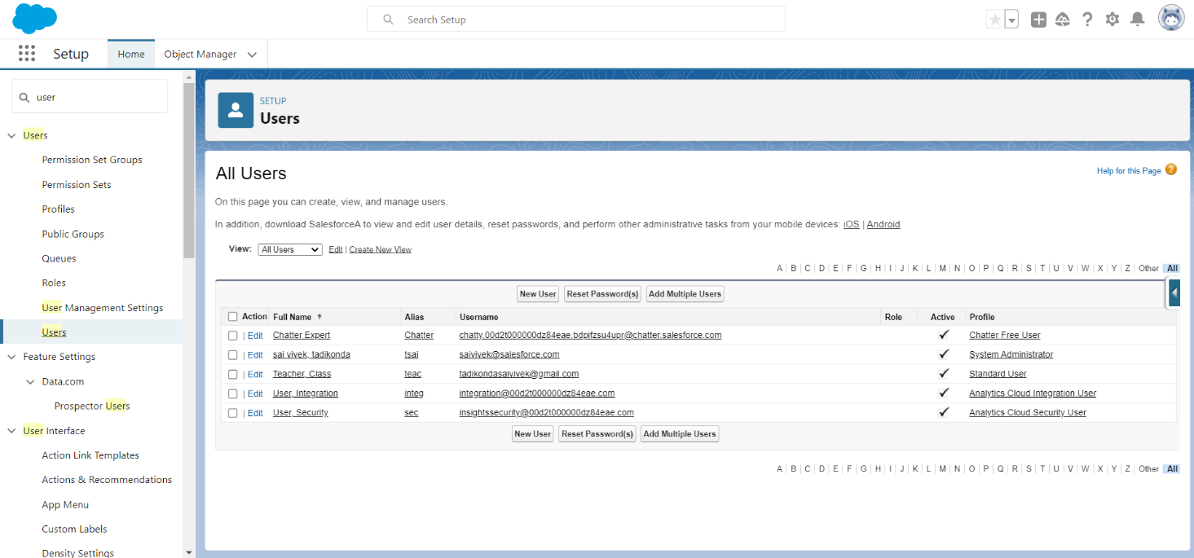

# Fields And Relationship’s

|  |  |  |
| --- | --- | --- |
| OBJECT NAME | FIELD NAME | DATA TYPE |
| Semester | Semester name | Text (standard field) |
|  | Course | Lookup (course details) |
| Candidate | Candidate name | Text (standard field) |
|  | Candidate roll  Number | Auto number |
|  | Semester name | Lookup(semester) |
| Lecturer details | Lecturer name | Text (standard field) |
|  | Lecturer role | Text |
|  | Course | Lookup(course) |
| Course details | Course name | Text (standard field) |
|  | Duration (years) | Number |
| Internal results | Candidate | Lookup (candidate) |
|  | Candidate roll number | Formula |
|  | Course | Lookup(course) |
|  | Marks | Number |

# Lightning App

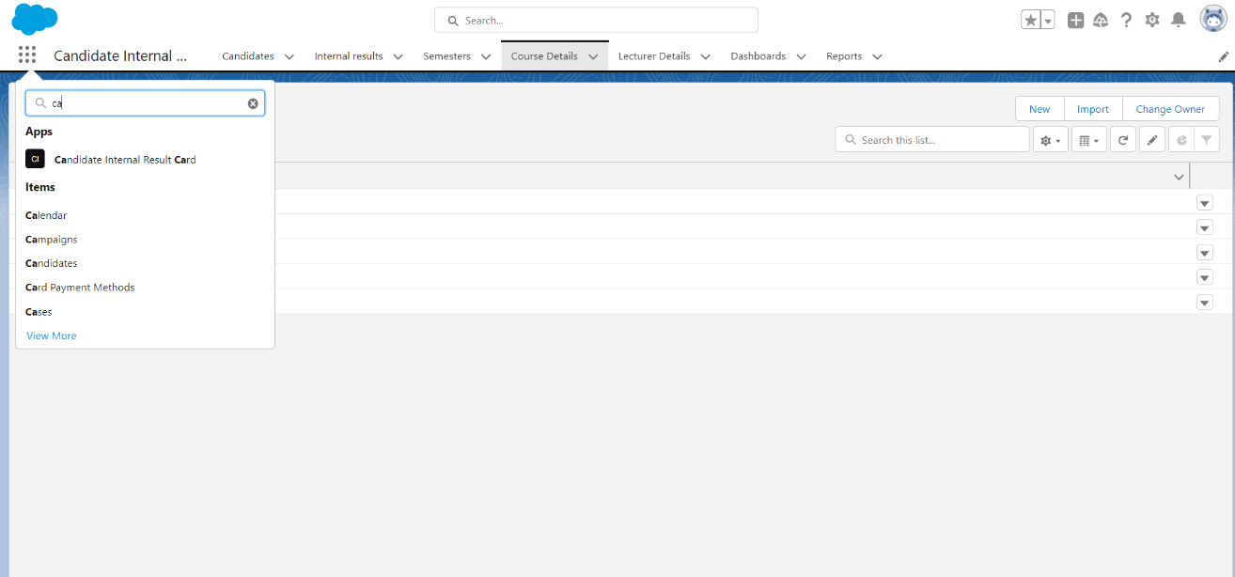

# Reports

# Tabs

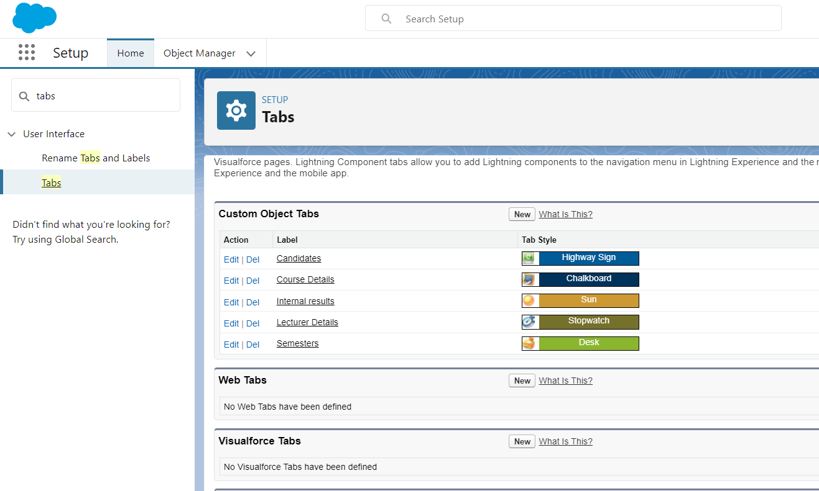

# Reports

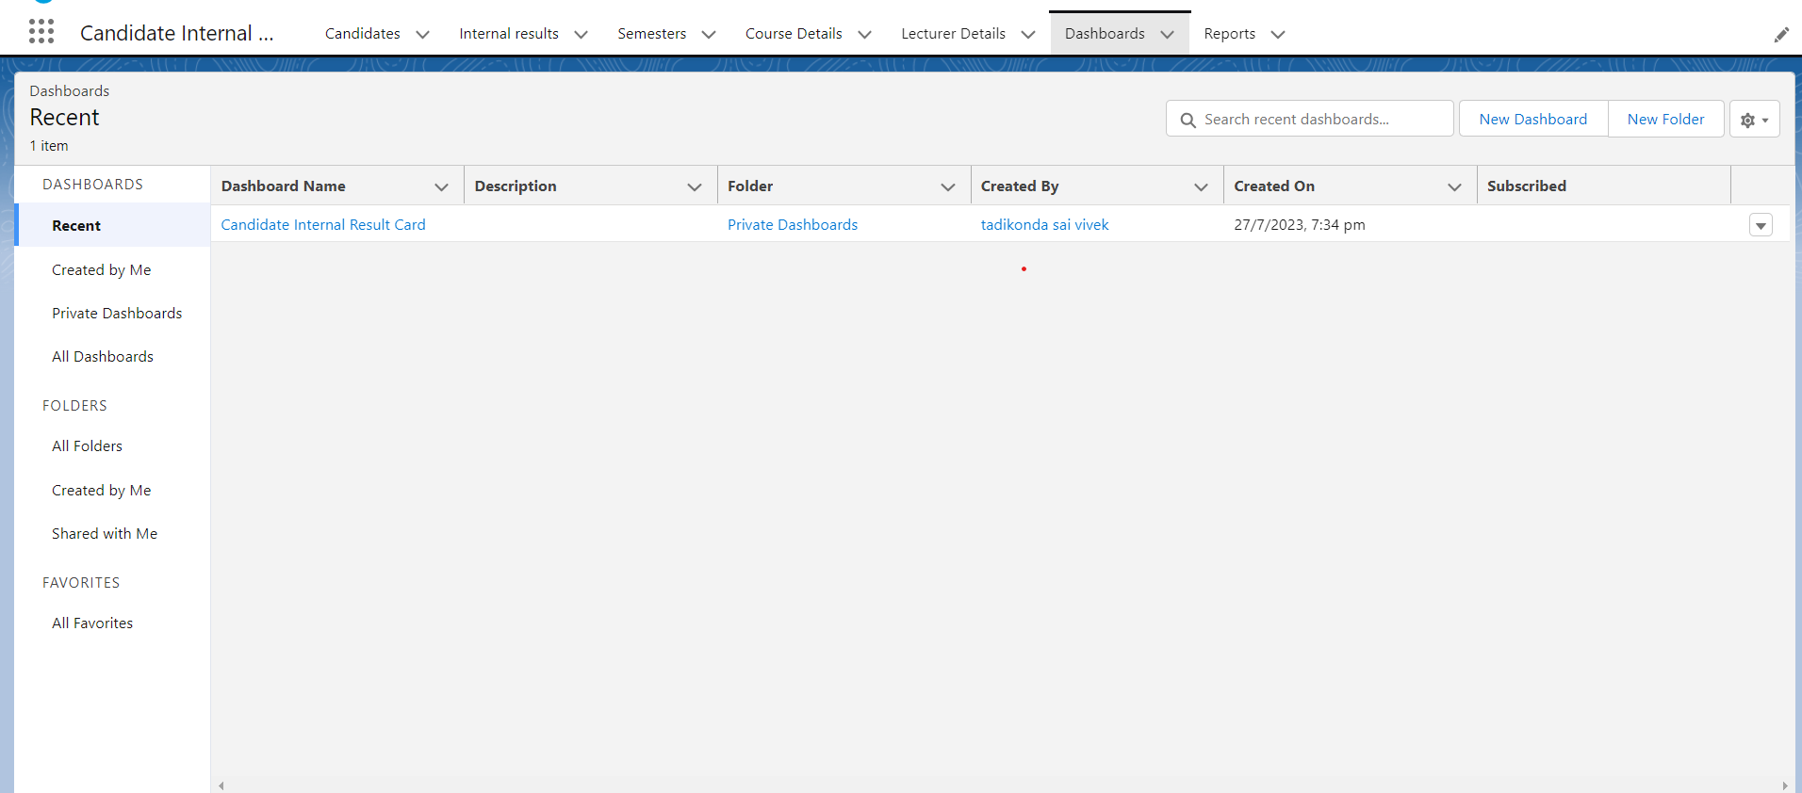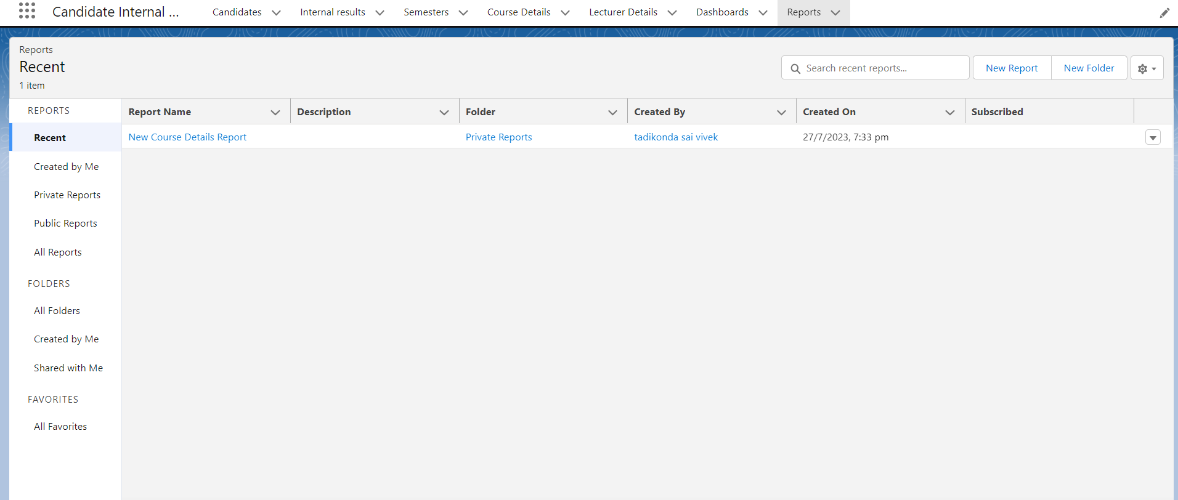Dashboard

Trailhead Profile Public URL

Team Lead - https://www.salesforce.com/trailblazer/suryakirankolaparthi

Team Member1 - www.salesforce.com/trailblazer/vamsipeddinti

Team Member2 - https://www.salesforce.com/trailblazer/gbp7

Team Member3 - https://www.salesforce.com/trailblazer/koteswararaokolli

Team Member4 - https://www.salesforce.com/trailblazer/bhagavatamsantoshkumar

# Advantages

1. It allows the consolidation of customer data and the basic data insights.
2. It speeds up sales conversion process.
3. It allows geographically dispersed team to collaborate effectively.
4. It increases the staff productivity lower the timing.
5. Improving customer experience by allowing personalization and improved query resolution.

# Disadvantages

1. CRM may not suitable for all businesses.
2. Data breach may be happened.
3. Security and data protection issues may happen due to centralized data.
4. Requires process driven sales organization.

# Applications

# I want something reliable.

# Can work easily.

# Streamlining internal sales processes.

# Conclusion

Student internal mark management system deals with student detail. Academic related reports collage details and course detail. It tracks all the detail of a student form the day one to the end his course which can be used for all reporting purpose tracking of progress. In the course completes, semester upcoming semester detail, Exam detail, Project or any other Assignment details, and exam result.

# Future Scope

Scope of education means range of view, outlook, field or opportunity of activity, operation and application of education. Education has a wider meaning and application.

*THANK YOU*